Java If-else Statement

The Java *if statement* is used to test the condition. It checks boolean condition: *true* or *false*. There are various types of if statement in java.

* if statement
* if-else statement
* if-else-if ladder
* nested if statement

Java IF Statement

The Java if statement tests the condition. It executes the *if block* if condition is true.

**Syntax:**

1. **if**(condition){
2. //code to be executed
3. }

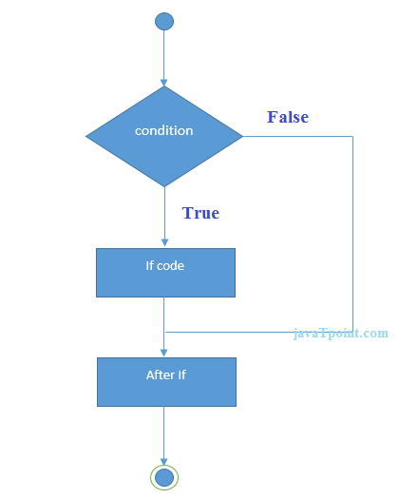

**Example:**

1. **public** **class** IfExample {
2. **public** **static** **void** main(String[] args) {
3. **int** age=20;
4. **if**(age>18){
5. System.out.print("Age is greater than 18");
6. }
7. }
8. }

Output:

Age is greater than 18

Java IF-else Statement

The Java if-else statement also tests the condition. It executes the *if block* if condition is true otherwise *else block* is executed.

**Syntax:**

1. **if**(condition){
2. //code if condition is true
3. }**else**{
4. //code if condition is false
5. }

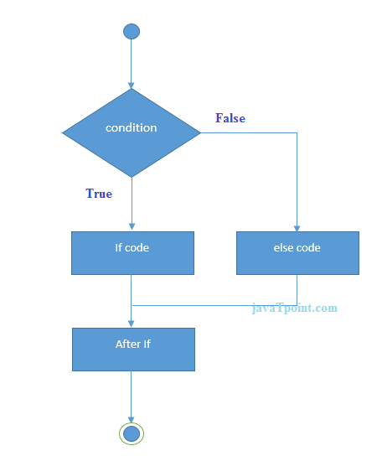

**Example:**

1. **public** **class** IfElseExample {
2. **public** **static** **void** main(String[] args) {
3. **int** number=13;
4. **if**(number%2==0){
5. System.out.println("even number");
6. }**else**{
7. System.out.println("odd number");
8. }
9. }
10. }

[**Test it Now**](https://compiler.javatpoint.com/opr/test.jsp?filename=IfElseExample)

Output:

odd number

Java IF-else-if ladder Statement

The if-else-if ladder statement executes one condition from multiple statements.

**Syntax:**

1. **if**(condition1){
2. //code to be executed if condition1 is true
3. }**else** **if**(condition2){
4. //code to be executed if condition2 is true
5. }
6. **else** **if**(condition3){
7. //code to be executed if condition3 is true
8. }
9. ...
10. **else**{
11. //code to be executed if all the conditions are false
12. }

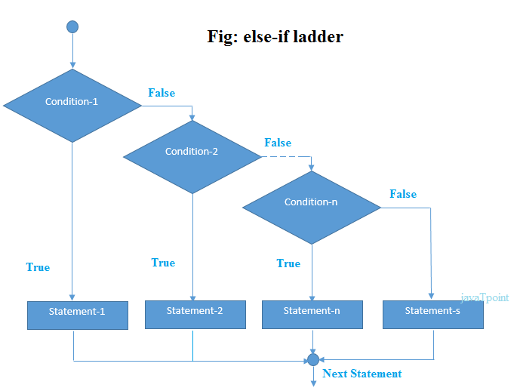

**Example:**

1. **public** **class** IfElseIfExample {
2. **public** **static** **void** main(String[] args) {
3. **int** marks=65;
5. **if**(marks<50){
6. System.out.println("fail");
7. }
8. **else** **if**(marks>=50 && marks<60){
9. System.out.println("D grade");
10. }
11. **else** **if**(marks>=60 && marks<70){
12. System.out.println("C grade");
13. }
14. **else** **if**(marks>=70 && marks<80){
15. System.out.println("B grade");
16. }
17. **else** **if**(marks>=80 && marks<90){
18. System.out.println("A grade");
19. }**else** **if**(marks>=90 && marks<100){
20. System.out.println("A+ grade");
21. }**else**{
22. System.out.println("Invalid!");
23. }
24. }
25. }

Output:

C grade